**UNIT 1. CORPORATE CULTURE**

**Students will be able to:**

|  |
| --- |
| * Understand and describe the meaning of corporate culture and its types. * Use vocabulary related to corporate culture |

**1.1 Warm-up activity: Associations with Corporate Culture**

1. Think of a word that you associate with the phrase **Corporate culture?**
2. Do you think that every enterprise or a company has its own culture?
3. Could you suggest answers for the culture that might exist in the business?

**READING**

**1.2 What is corporate culture?**

Corporate culture encompasses the shared values, attitudes, and practices that shape a company’s operations. It influences how employees interact with each other and customers. To cultivate a positive culture, promote open communication, recognize achievements, and align company practices with core values.

Corporate culture can be a factor in a company’s success. A strong and positive corporate culture helps workers feel more secure, allowing them to identify their career success with the success of the company. According to PwC’s 2021 Global Culture Survey, business leaders whose company has a distinctive culture were 80% more likely to report employee satisfaction than those at companies without a distinctive culture.

*Retrieved from:* [*https://www.shopify.com/blog/what-is-corporate-culture*](https://www.shopify.com/blog/what-is-corporate-culture)*. 06.24.2025. 1:52pm.*

**1.3** Watch the video “What is Corporate Culture” on YouTube [[**https://www.youtube.com/watch?v=hhcSIhlx02Q**](https://www.youtube.com/watch?v=hhcSIhlx02Q)] and answer the questions?

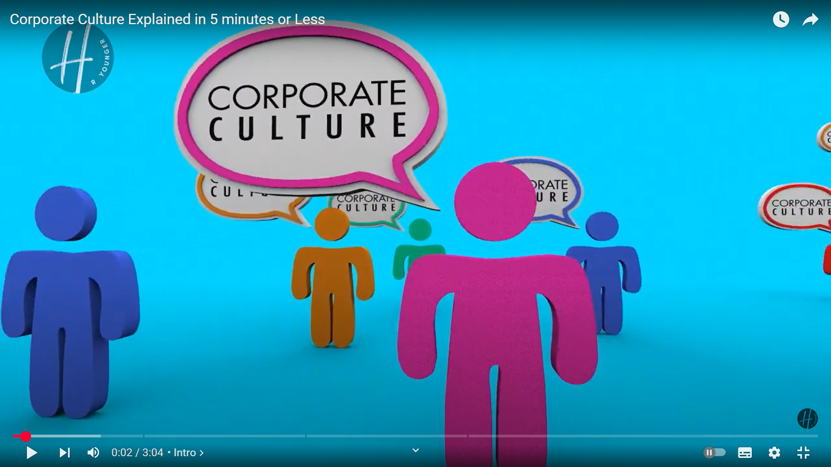

**1.1 Answer the following questions.**

1. What does "corporate culture" mean to you personally?
2. Why do you think corporate culture is important in business?
3. How does the video define corporate culture?
4. What are some of the key elements that shape a company’s culture?
5. Can you list two examples of how corporate culture influences employee behavior?
6. What role do leaders play in shaping and maintaining culture?
7. What are the consequences if a company's culture is not aligned with its employees' values?

**VOCABULARY**

**1.2** **Match the words with their definitions**

|  |  |
| --- | --- |
| 1. Retention | A. Unpredictable and disorganized |
| 1. Empowerment | B. Having control or strong influence |
| 1. Ruthless | C. The ability to create new ideas or methods |
| 1. Adhocracy | D. Assessment or evaluation of performance |
| 1. Bureaucratic | E. Lacking interest or emotional connection |
| 1. Appraisal | F. Without pity or compassion, often harsh |
| 1. Innovation | G. A type of organization culture focused on innovation and risk-taking |
| 1. Disengaged | H. Encouraging people to take control of decisions |
| 1. Chaotic | I. Staying in a job for a long time |
| 1. Authoritative | J. Formal system with many levels and rules |

**SPEAKING ACTIVITY**

* 1. Discuss the key differences in corporate culture between a multinational company like ***Google LLC*** (USA) and a family-owned company ***Anglesey LLC Korzinka*** (Uzbekistan)

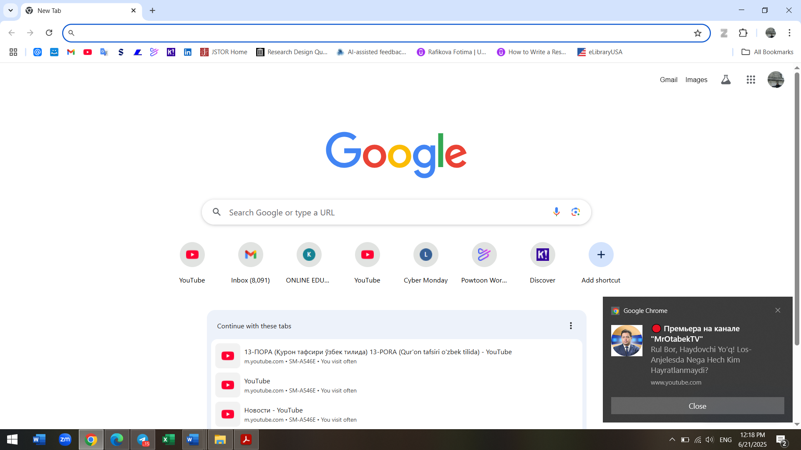 

Use the following promts to make up comparing and contrasting sentences

Sentence Starters for Comparing:

* "Both Google and Korzinka focus on …"
* "One similarity between Google and Korzinka is that they value …"
* "Just like Google, Korzinka also emphasizes …"
* "A common feature of both companies is that they promote …"

Sentence Starters for Contrasting:

* "Google tends to be innovative, whereas Korzinka is more traditional because …"
* "While Google encourages a flexible work environment, Korzinka prefers a structured one, which means …"
* "Google’s culture is more informal compared to Korzinka’s, which is more formal, for example …"
* "In terms of employee motivation, Google is more reward-based, while Korzinka relies heavily on personal relationships because …"

**READING PASSAGE**

**1.4** Read the article below and find the title that matches the passage

1. The most important culture of the company
2. Four different types of culture explained
3. Corporate culture and its importance

A strong company culture is critical to business success. If done poorly, it can hurt employee retention, productivity, and engagement. To understand and improve your culture, use the Competing Values Framework, which outlines four main types: Clan, Adhocracy, Market, and Hierarchy cultures.

Clan Culture – *“The Family”* Clan culture is friendly, collaborative, and people-focused. Employees often share similar values and feel a strong sense of belonging. Leaders act like mentors, focusing on team building, involvement, and empowerment.

Pros: Strong relationships, positive environment, shared vision.  
Cons: Too much freedom can lead to lack of authority, imbalance, or disengagement.

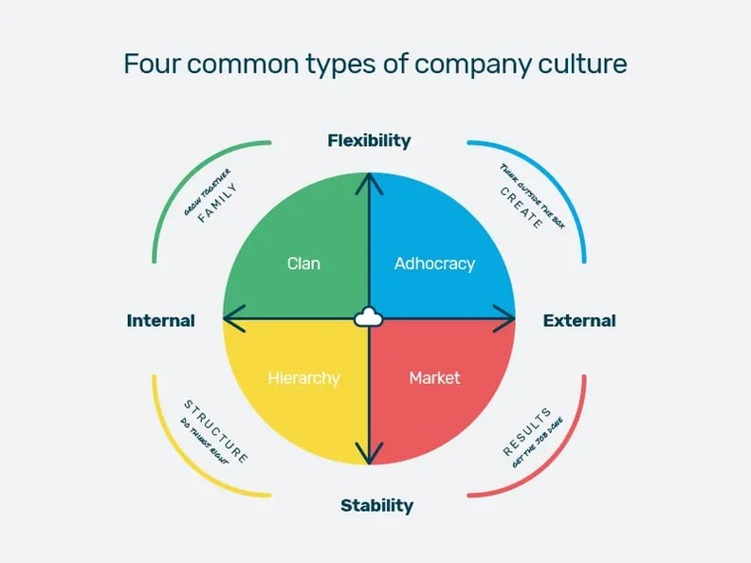Adhocracy Culture – *“The Innovator”*

Adhocracy comes from Latin *ad hoc* ("for this"). It values innovation, risk-taking, and flexibility. Found in fast-moving industries like tech, it encourages experimentation and quick adaptation to trends.

Pros: Creative, energetic, future-focused.  
Cons: Can feel chaotic, with unclear roles. Risky ideas may hurt financial stability.

Market Culture – *“The Competitor”*

Market culture is performance-oriented and highly competitive. The focus is on results, profit, and gaining market share. Leaders are demanding, and employees are expected to set and meet challenging goals.

Pros: Strong motivation, clear objectives, measurable success.  
Cons: High pressure can lead to conflict, dishonesty, and burnout.

Hierarchy Culture – *“The Organizer”*

Hierarchy culture values structure, control, and doing things “by the book.” It features multiple management levels, clear procedures, and well-defined responsibilities. Think of large, bureaucratic organizations.

Pros: Order, efficiency, clear communication lines.  
Cons: Can be slow-moving, overly rigid, with limited personal development.

Author **Sarah Benstead**

*Retrieved and adapted from:* [*4 different types of company culture explained*](https://www.breathehr.com/en-gb/blog/topic/company-culture/4-different-types-of-company-culture-explained?utm_source=chatgpt.com) *06.11.2025. 10:06am*

**1.5 Comprehension Questions**

1. Which culture is like a family and focuses on teamwork?
2. Which culture encourages new ideas and risk‑taking?
3. Which type of corporate culture you like the most?
4. What is a main weakness of Market Culture?

**1.6 Match each culture with its feature (draw lines):**

1. Clan Culture a) Structured with many rules
2. Adhocracy Culture b) Risk-taking and creative
3. Market Culture c) Competitive and result-focused
4. Hierarchy Culture d) Teamwork and collaboration

**ADDITIONAL ACTIVITY**

**AI generated activity**

* 1. **Scenario-Based Practice (10 minutes)**:

I’ll present a simple scenario where students imagine they are part of a company with a specific type of corporate culture (e.g., a collaborative team environment).

Students will practice a short dialogue where they discuss how to implement a new idea in this type of culture. I’ll provide prompts and sentence starters to help guide them.

* 1. **Vocabulary Review (5 minutes)**:

I’ll introduce a few key terms related to corporate culture, such as "collaboration," "innovation," "hierarchy," and "teamwork."

For A2-level students, I’ll provide simple definitions and example sentences. For B2-level students, I’ll encourage them to create their own sentences using the vocabulary.

|  |  |  |
| --- | --- | --- |
| **Word** | **Simple Definition** | **Example Sentence** |
| **Teamwork** | Working well together in a group | “Teamwork helps employees finish projects faster.” |
| **Innovation** | Creating new and smart ideas | “Innovation is important in companies like Google.” |
| **Hierarchy** | A structure with different levels of power | “In a hierarchy, the manager makes the decisions.” |
| **Flexible** | Easy to change or adapt | “This company has flexible working hours.” |

**Class 2: AI Segment (15 minutes)**

* 1. **Listen to a short audio clip (5 minutes)**:

I’ll play a brief audio clip that explains one type of corporate culture in simple terms. The clip will be easy to understand for A2-level students but still informative for B2 students.

1. **Comprehension Questions (5 minutes)**:

After listening, I’ll ask a few comprehension questions about the clip. For A2 students, the questions will be straightforward (e.g., "What type of culture was described?"). For B2 students, I might ask slightly more detailed questions (e.g., "How does this culture influence employee behavior?").

* 1. **Group Reflection (5 minutes)**:

I’ll lead a short reflection where students share what they found interesting or new about the type of culture described. I’ll provide sentence starters to help everyone participate, regardless of their level.

**Home work**

Watch the following additional explanation of the video about Corporate culture and write about your own future company that you would like launch in the future. [https://www.youtube.com/watch?v=v0_OY8G2AZg]

**UNIT 1. INTRODUCTION & CORPORATE CULTURE**

Business meeting started at 5 pm. But something went wrong and people were waiting for the organizer to start the meeting.

The fixed time for the meeting was 5pm but because of some delays it started later. The people were waiting for the meeting to start.

The past simple describes a completed action in the past, while the past continuous describes a longer, ongoing action in the past, often at a specific time or interrupted by another action.

**Watch and https://www.youtube.com/watch?v=hhcSIhlx02Q**

**1.6** **Fill in the blanks using past simple or past continuous forms of the verbs in brackets.**

1. The manager ________ (explain) the new corporate culture when the employees ________ (arrive) at the meeting.
2. While I ________ (prepare) my report, my colleague ________ (talk) to the CEO about our company's clan culture.
3. Yesterday, our team ________ (discuss) hierarchy culture, and we ________ (decide) it was too rigid for our style.
4. I ________ (read) about adhocracy culture when the phone ________ (ring).
5. Last month, we ________ (organize) a team-building event to improve our corporate culture, and everyone ________ (enjoy) it.

**1.7** **Read an excerpt and find the verbs in the Past Simple.**

This time, I **nudged** Orif a little harder, and his eyes **went** wide with panic—he **started** whispering out of fear. Whatever he **said**, I **repeated** it word for word without missing a beat.

The whole class burst into laughter. I **joined** in too, laughing heartily. Later, I **found** out that instead of saying *"teng"* (equal), I had **said** *"eng"* (topmost).

“Come on, give us the definition,” the teacher **said**, trying to calm the laughter.

“It’s right on the tip of my tongue, but I just can’t say it,” I **replied**, pretending to struggle.

Saying that, I **looked up** at the ceiling, out the window, at the blackboard. After three or four minutes, the teacher **asked** again, “Well, are you going to say it or not?”

Excerpt from Riding the yellow Giant by Hudoyberdi Tohtaboyev [1]

**1.2 Answer the following questions based on the passage:**

1. Why did Orif start whispering?
2. What mistake did the narrator make when repeating Orif’s words?
3. How did the class react to the mistake?
4. What did the teacher ask the narrator to do?
5. How did the narrator try to avoid answering?

**MODAL VERBS *SHOULD / OUGHT TO / IT'S A GOOD IDEA TO***

These expressions are used to give advice or make recommendations. They suggest what is the right, sensible, or best thing to do in a given situation — but they are not as strong as commands.

*You* ***should*** *wear your scarf as it is snowing outside.*

*It’s* ***a good idea to*** *launch this new product.*

*You* ***ought to*** *take your medicine on time to recover.*

**1.1 Complete the sentences using** **should**, **ought to**, or **it's a good idea to**.

1. Companies __________ clearly explain their corporate culture to new employees.
2. If your business feels disorganized, you __________ consider adopting a hierarchy culture.
3. To encourage creativity, management __________ adopt an adhocracy culture.
4. If team spirit is low, __________ introduce a clan culture.
5. Employees __________ understand the corporate culture before they join a company.

**Exercise 1.8: Correct the Mistakes**

Each sentence below contains an error. Correct it.

1. Yesterday, I was attend a seminar about corporate culture.
2. While our team discussed ideas, the manager suddenly was entering the room.
3. It’s a good idea introducing clan culture to build trust.
4. They ought organize team-building activities regularly.
5. She should have explained corporate values when the new staff arrive.

**UNIT 3. INTRODUCTION & CORPORATE CULTURE**

**Objectives:** Students will be able to listen to a dialogue about a meeting in a company and simulate the activity.

**Giving Advice About Corporate Culture**

**Scene:** An employee (Anna) is meeting with her manager (Mr. Brown) to discuss how to improve teamwork in their company.



*Two coworkers brainstorming at a board [Stock image]. (n.d.). Creative Content Library.10:03. 06.21.2025*

**Exercise 2. One-to-One Meetings Role-play**

**Preparation:** Put students in pairs. One student plays the manager, the other plays the employee. Use the prompts below and make up a simulation about meeting.

**Situation 1: Feedback Meeting**

**Scenario:** The employee is not adjusting well to the new corporate culture. The manager gives advice.

|  |  |
| --- | --- |
| **Useful phrases for managers:**   * I think you should try... * It’s a good idea to... * You might want to consider... * You ought to... | **Useful phrases for employees:**   * That’s a good suggestion. * I’ll try to... * I hadn’t thought of that. * Thanks for the advice. |

**Practical Ways to Use AI Chatbots in Your Coursebook (Unit 1: Corporate Culture)**

Here are explicit examples suitable for your provided draft on Corporate Culture:

**1. Vocabulary & Comprehension Activities:**

* **Task Example:**

"Chat with ChatGPT to generate five sentences using the words: innovation, teamwork, hierarchy, flexible, empowerment. Then identify their meanings."

* **Goal:** Vocabulary retention and contextual use.

**2. Role-play Simulations:**

* **Task Example:**

"Using Character.ai, have a dialogue with 'virtual Elon Musk' about Tesla’s corporate culture. Summarize key points and discuss how they could apply to Korzinka."

* **Goal:** Authentic speaking practice and critical thinking.

**3. Scenario-based Decision-making:**

* **Task Example:**

"Use ChatGPT to role-play a meeting scenario where you need to implement a new corporate culture (adhocracy) in a traditional company. Discuss possible issues and solutions."

* **Goal:** Business English fluency and problem-solving.

**4. Grammar & Writing Tasks:**

* **Task Example:**

"Ask Google Bard or ChatGPT to correct the following sentences for past tense accuracy and rewrite them professionally in a business context."

* **Goal:** Grammar accuracy and business communication skills.

**5. AI-Generated Feedback and Evaluation:**

* **Task Example:**

"Submit your short written summary about 'clan culture' to ChatGPT for grammar correction, feedback, and suggestions for improvement."

* **Goal:** Immediate personalized feedback.

**Incorporating AI Chatbots into Your Dissertation:**

Given your dissertation's aim of **developing professional communicative competence in digital learning contexts**, you might:

**Theoretical framework:**

* Discuss how chatbots like ChatGPT can support communicative competence (interaction, fluency, accuracy, negotiation skills).

**Methodology (experimental design):**

* Conduct controlled experiments comparing student groups using traditional Business English instruction vs. chatbot-assisted learning.

**Results analysis:**

* Quantify improvements in language skills, confidence, engagement, and motivation using chatbots.

**Pedagogical recommendations:**

* Develop clear guidelines for effectively integrating chatbots in ESP (English for Specific Purposes) classrooms.

**Benefits of AI Chatbots in Business English:**

* **Instant Interaction:** Real-time conversational practice and immediate feedback.
* **Personalization:** Adapt responses to individual student proficiency levels.
* **Engagement:** Increase motivation through innovative learning experiences.
* **Scalability:** Easy to replicate across multiple courses/classes.

**Potential Dissertation Research Questions to Consider:**

* How does regular interaction with AI chatbots influence students’ professional communicative competence?
* Which AI chatbot-assisted tasks most effectively enhance business English vocabulary retention and usage?
* What is the impact of using AI chatbots on students’ confidence and fluency in Business English contexts?

**Example Task for Your Coursebook (Ready-to-use):**

**Coursebook Task (Unit 1. AI activity):**

**AI Dialogue Practice: Corporate Culture Simulation (15 min)**

**Step 1 (5 min):**  
Chat with ChatGPT. Type:  
*“Let's role-play a dialogue. I'm a manager at a traditional company (Hierarchy culture). Convince me to adopt a more flexible (Adhocracy) culture.”*  
Copy three arguments that ChatGPT provides.

**Step 2 (5 min):**  
Now, summarize these arguments in your own words.

**Step 3 (5 min, Pair work):**  
Share your summary with your partner. Discuss which argument was the most convincing and why.

By integrating AI chatbots in these structured ways, you strengthen your coursebook's modern appeal, align closely with your dissertation goals, and engage students in practical, innovative learning activities.

**[Transcript**

Brown: Good morning, Anna. I wanted to get your opinion on how we can improve teamwork in our company. Some employees feel disconnected.

Anna: Yes, I’ve noticed that too. Maybe we can organize some team-building activities.

Mr. Brown: That’s a good idea. Actually, you should prepare a list of possible activities for next month.

Anna: Sure, I can do that. Do you have any other suggestions?

Mr. Brown: Yes, I think you ought to talk to each department and ask what activities they would enjoy.

Anna: That’s helpful. What about improving communication between departments?

Mr. Brown: Hmm… It’s a good idea to create a weekly meeting where team leaders can share updates and discuss issues together.

Anna: I like that. It will help everyone stay informed.

Mr. Brown: Exactly. And if I were you, I would also set up a shared online platform where teams can easily exchange information.

Anna: That’s great advice! Should we also set some ground rules for teamwork?

Mr. Brown: Yes, absolutely. Why don’t you prepare a simple guide with teamwork rules and expectations?

Anna: I’ll work on that. Anything else?

Mr. Brown: One more thing: You’d better inform the HR department about these changes so they can support us.

Anna: Of course. Thank you for all the suggestions!

Mr. Brown: Thank you, Anna. I appreciate your ideas and initiative.

1. Riding the yellow Giant by Hudoyberdi Tohtaboyev